STOCK MANAGEMENT SYSTEM

USECASE DIAGARM:

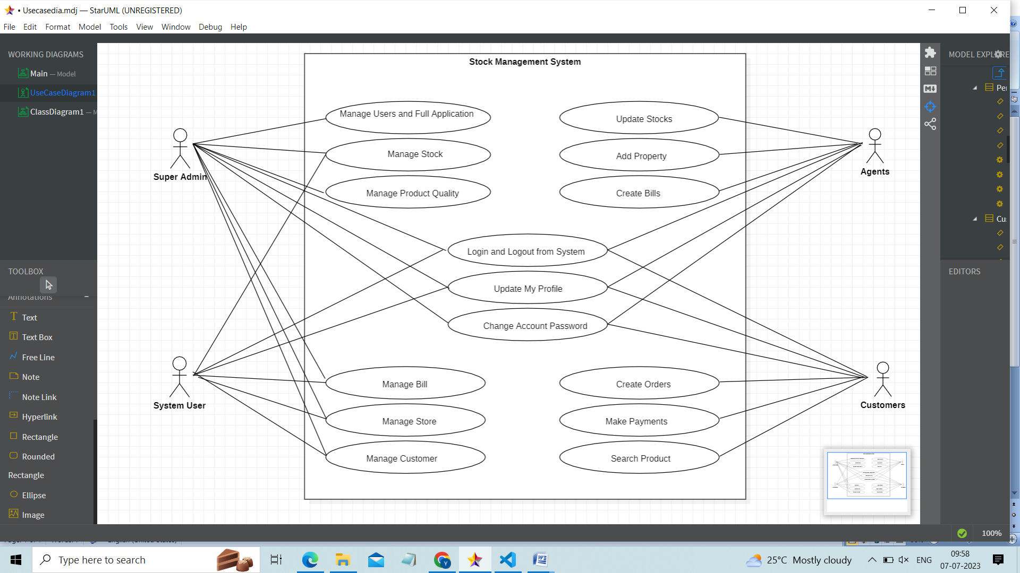

CLASS DIAGRAM:  
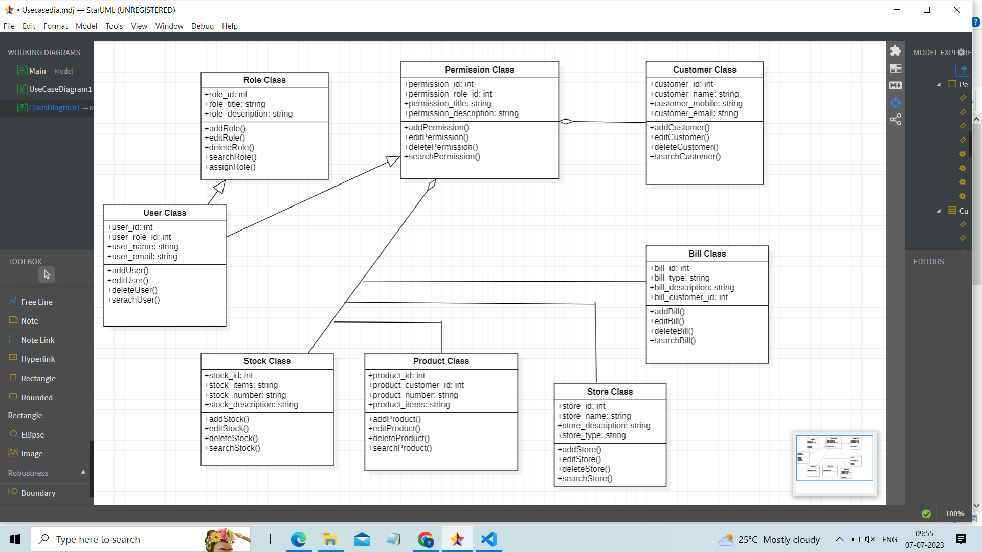

SEQUENCE DIAGRAM:

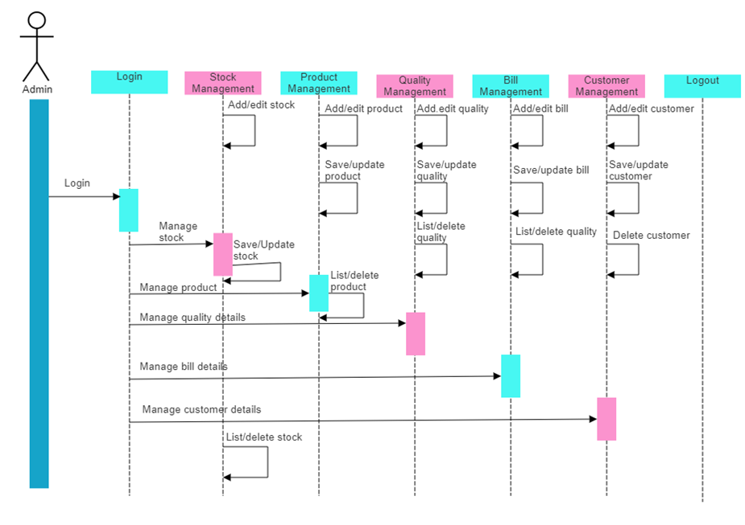

ER DIAGRAM:

